Welcome to Pennsylvania, America Dumps Here
[This map does not include the many landfills and incinerators which are either closed or which were proposed, but defeated.
It also does not include waste transfer stations, or facilities for fly ash, hazardous waste or medical wastes.]
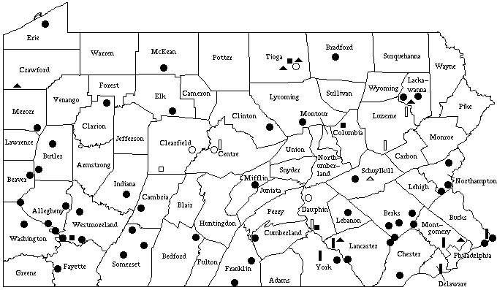
Municipal Solid Waste Landfills (48 existing; 4 proposed)
Residual Waste Landfills (4 existing, including the Harrisburg ash dump; 1 proposed)
Construction & Demolition Waste Landfills (6 existing; 1 proposed)
Municipal Solid Waste Incinerators (5 existing; 4 proposed)

Solid symbols are existing facilities; Hollow ones are proposed.
- Since at least 1992, Pennsylvania has been the largest importer of waste, with Virginia a distant 2nd. Of all the municipal solid waste that crosses state lines for disposal, 23 percent comes to Pennsylvania.

- In 2003, Pennsylvania accepted waste from 28 states (including DC), plus Puerto Rico and Canada. 94% of these imports were from New Jersey and New York.

- Pennsylvania’s Department of Environmental Protection (DEP) has permitted waste facilities in the state to accept three times as much waste per year as Pennsylvania generates.

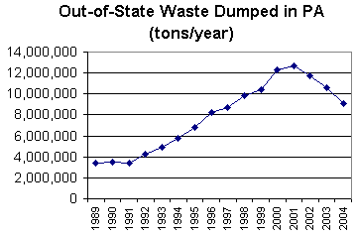

Waste imports can be halted dramatically if Pennsylvania legislators did the following:
(without needing federal legislation to deal with the Interstate Commerce Clause)

- Rescind the excess permitted yearly volume at PA landfills and incinerators, rolling it back to the amount of waste that is actually dumped in the state.
- Roll that level back further – at about 10% a year – until it reaches the amount of waste generated yearly by Pennsylvanians. Currently, Pennsylvania receives nearly twice as much as it generates.
- Plan further reductions to accommodate source reduction, composting and recycling.

This plan would stretch out the life of our landfills, filling them slower and reducing the need for expansions.

© 2005 Mike Ewall 215-743-4884 catalyst@actionpa.org www.ActionPA.org/waste/

